**EX 1-b**

**code**

import pandas

import numpy as np

import matplotlib.pyplot as plt

roles=['Data Analyst','Data Engineer','Data Scientist','Ml Engineer','Machine Engineer']

count=np.array([250,300,350,400,450])

plt.pie(count,labels=roles)

plt.title('Various Data Science Roles')

plt.xlabel('roles')

plt.ylabel('Various Job Postings')

plt.legend

plt.show()

**output**

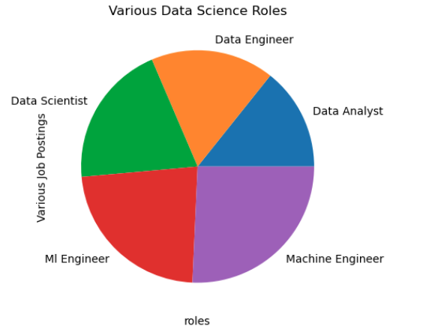

**Code**

import pandas as pd

import matplotlib.pyplot as plt

roles=['data scientist','data analyst','data engineer','ml engineer','business analyst']

counts=[300,500,450,200,150]

plt.bar(roles,counts,width=0.5)

plt.title('distributive of data science roles')

plt.xlabel('roles')

plt.ylabel('counts')

plt.show()

**output**

